1.Create a package CIE which has two classes- Student and Internals. The class Personal has members like usn, name, sem. The class internals has an array that stores the internal marks scored in five courses of the current semester of the student. Create another package SEE which has the class External which is a derived class of Student. This class has an array that stores the SEE marks scored in five courses of the current semester of the student. Import the two packages in a file that declares the final marks of n students in all five courses.

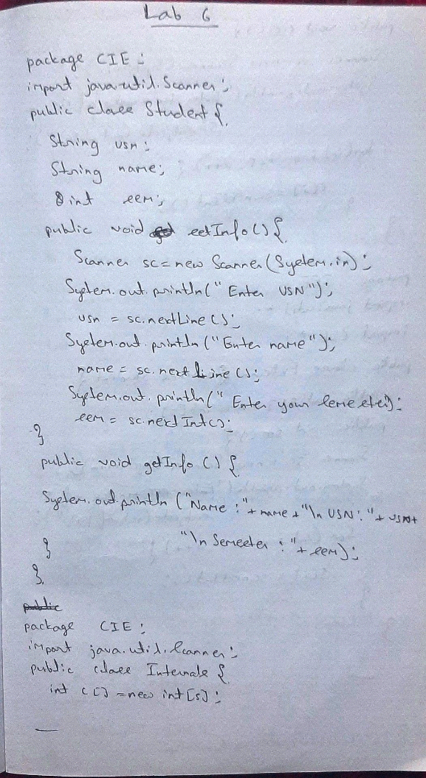

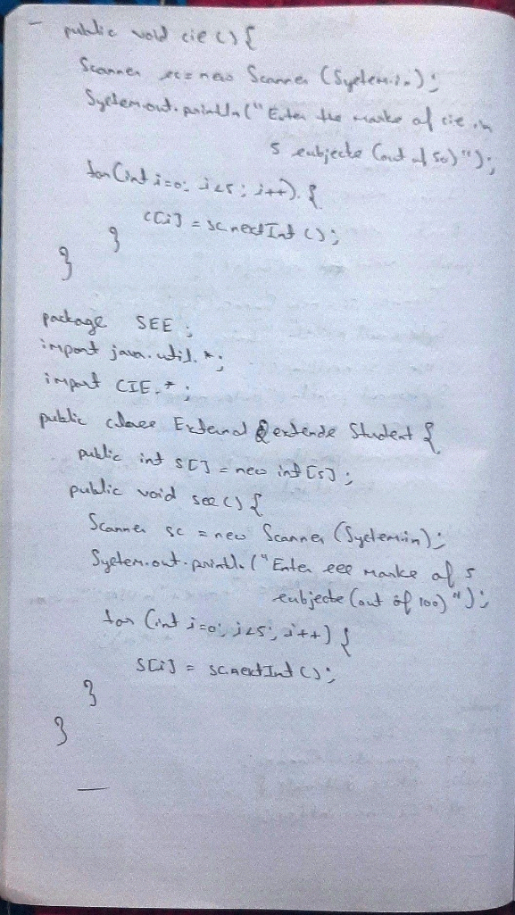

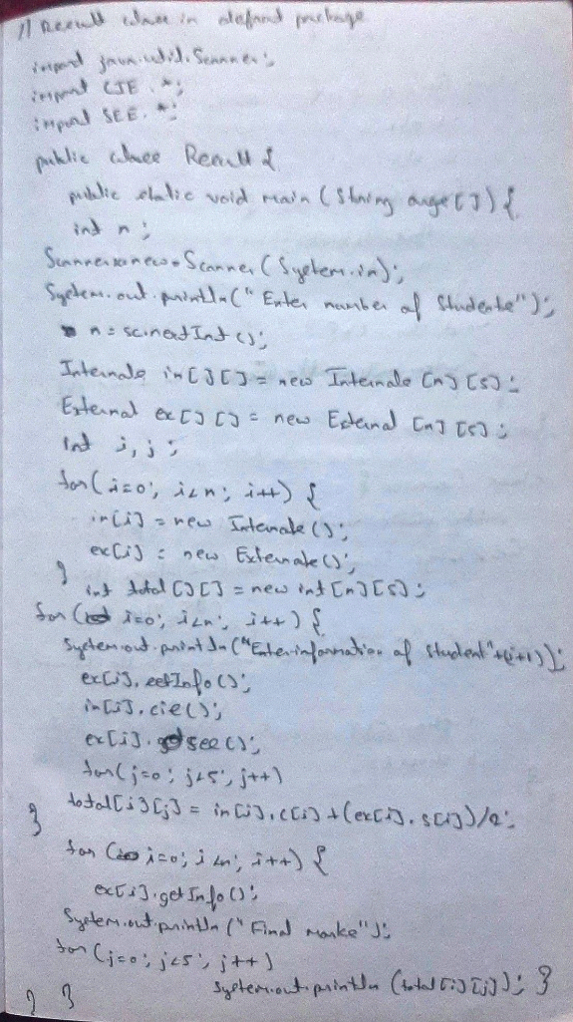

package CIE;

import java.util.\*;

public class Internals{

public int c[]=new int[5];

public void cie(){

Scanner sc = new Scanner(System.in);

System.out.println("Enter the cie marks in 5 subjects(out of 50)");

for(int i=0;i<5;i++)

c[i]=sc.nextInt();

}

}

package CIE;

import java.util.\*;

public class Student{

public String usn;

public String name;

public int sem;

public void setInfo(){

Scanner sc=new Scanner(System.in);

System.out.println("Enter usn");

usn=sc.nextLine();

System.out.println("Enter name");

name=sc.nextLine();

System.out.println("Enter semester");

sem=sc.nextInt();

}

public void getInfo(){

System.out.println("USN :"+usn+"\nName :"+name+"\nSemester :"+sem);

}

}

package SEE;

import CIE.\*;

import java.util.\*;

public class External extends Student{

public int s[]=new int[5];

public void see(){

Scanner sc = new Scanner(System.in);

System.out.println("Enter the see marks in 5 subjects(out of 100)");

for(int i=0;i<5;i++)

s[i]=sc.nextInt();

}

}

import java.util.\*;

import SEE.\*;

import CIE.\*;

public class Result{

public static void main(String args[]){

int n;

Scanner sc = new Scanner(System.in);

System.out.println("Enter number of students");

n=sc.nextInt();

Internals in[] = new Internals[n];

External ex[] = new External[n];

for(int i=0;i<n;i++){

in[i]=new Internals();

ex[i]=new External();

}

int total[][]=new int[n][5];

for(int i=0;i<n;i++){

System.out.println("Enter information of Student "+(i+1));

ex[i].setInfo();

in[i].cie();

ex[i].see();

for(int j=0;j<5;j++){

total[i][j]=in[i].c[j]+(ex[i].s[j])/2;

}

}

for(int i=0;i<n;i++){

ex[i].getInfo();

System.out.println("Final marks");

for(int j=0;j<5;j++)

System.out.println(total[i][j]);

}

}

}

import java.util.\*;

import SEE.\*;

import CIE.\*;

public class Result{

public static void main(String args[]){

int n;

Scanner sc = new Scanner(System.in);

System.out.println("Enter number of students");

n=sc.nextInt();

Internals in[] = new Internals[n];

External ex[] = new External[n];

for(int i=0;i<n;i++){

in[i]=new Internals();

ex[i]=new External();

}

int total[][]=new int[n][5];

for(int i=0;i<n;i++){

System.out.println("Enter information of Student "+(i+1));

ex[i].setInfo();

in[i].cie();

ex[i].see();

for(int j=0;j<5;j++){

total[i][j]=in[i].c[j]+(ex[i].s[j])/2;

}

}

for(int i=0;i<n;i++){

ex[i].getInfo();

System.out.println("Final marks");

for(int j=0;j<5;j++)

System.out.println(total[i][j]);

}

}

}

import java.util.\*;

import SEE.\*;

import CIE.\*;

public class Result{

public static void main(String args[]){

int n;

Scanner sc = new Scanner(System.in);

System.out.println("Enter number of students");

n=sc.nextInt();

Internals in[] = new Internals[n];

External ex[] = new External[n];

for(int i=0;i<n;i++){

in[i]=new Internals();

ex[i]=new External();

}

int total[][]=new int[n][5];

for(int i=0;i<n;i++){

System.out.println("Enter information of Student "+(i+1));

ex[i].setInfo();

in[i].cie();

ex[i].see();

for(int j=0;j<5;j++){

total[i][j]=in[i].c[j]+(ex[i].s[j])/2;

}

}

for(int i=0;i<n;i++){

ex[i].getInfo();

System.out.println("Final marks");

for(int j=0;j<5;j++)

System.out.println(total[i][j]);

}

}

}

import java.util.\*;

import SEE.\*;

import CIE.\*;

public class Result{

public static void main(String args[]){

int n;

Scanner sc = new Scanner(System.in);

System.out.println("Enter number of students");

n=sc.nextInt();

Internals in[] = new Internals[n];

External ex[] = new External[n];

for(int i=0;i<n;i++){

in[i]=new Internals();

ex[i]=new External();

}

int total[][]=new int[n][5];

for(int i=0;i<n;i++){

System.out.println("Enter information of Student "+(i+1));

ex[i].setInfo();

in[i].cie();

ex[i].see();

for(int j=0;j<5;j++){

total[i][j]=in[i].c[j]+(ex[i].s[j])/2;

}

}

for(int i=0;i<n;i++){

ex[i].getInfo();

System.out.println("Final marks");

for(int j=0;j<5;j++)

System.out.println(total[i][j]);

}

}

}

import java.util.\*;

import SEE.\*;

import CIE.\*;

public class Result{

public static void main(String args[]){

int n;

Scanner sc = new Scanner(System.in);

System.out.println("Enter number of students");

n=sc.nextInt();

Internals in[] = new Internals[n];

External ex[] = new External[n];

for(int i=0;i<n;i++){

in[i]=new Internals();

ex[i]=new External();

}

int total[][]=new int[n][5];

for(int i=0;i<n;i++){

System.out.println("Enter information of Student "+(i+1));

ex[i].setInfo();

in[i].cie();

ex[i].see();

for(int j=0;j<5;j++){

total[i][j]=in[i].c[j]+(ex[i].s[j])/2;

}

}

for(int i=0;i<n;i++){

ex[i].getInfo();

System.out.println("Final marks");

for(int j=0;j<5;j++)

System.out.println(total[i][j]);

}

}

}

import java.util.\*;

import SEE.\*;

import CIE.\*;

public class Result{

public static void main(String args[]){

int n;

Scanner sc = new Scanner(System.in);

System.out.println("Enter number of students");

n=sc.nextInt();

Internals in[] = new Internals[n];

External ex[] = new External[n];

for(int i=0;i<n;i++){

in[i]=new Internals();

ex[i]=new External();

}

int total[][]=new int[n][5];

for(int i=0;i<n;i++){

System.out.println("Enter information of Student "+(i+1));

ex[i].setInfo();

in[i].cie();

ex[i].see();

for(int j=0;j<5;j++){

total[i][j]=in[i].c[j]+(ex[i].s[j])/2;

}

}

for(int i=0;i<n;i++){

ex[i].getInfo();

System.out.println("Final marks");

for(int j=0;j<5;j++)

System.out.println(total[i][j]);

}

}

}

import java.util.\*;

import SEE.\*;

import CIE.\*;

public class Result{

public static void main(String args[]){

int n;

Scanner sc = new Scanner(System.in);

System.out.println("Enter number of students");

n=sc.nextInt();

Internals in[] = new Internals[n];

External ex[] = new External[n];

for(int i=0;i<n;i++){

in[i]=new Internals();

ex[i]=new External();

}

int total[][]=new int[n][5];

for(int i=0;i<n;i++){

System.out.println("Enter information of Student "+(i+1));

ex[i].setInfo();

in[i].cie();

ex[i].see();

for(int j=0;j<5;j++){

total[i][j]=in[i].c[j]+(ex[i].s[j])/2;

}

}

for(int i=0;i<n;i++){

ex[i].getInfo();

System.out.println("Final marks");

for(int j=0;j<5;j++)

System.out.println(total[i][j]);

}

}

}

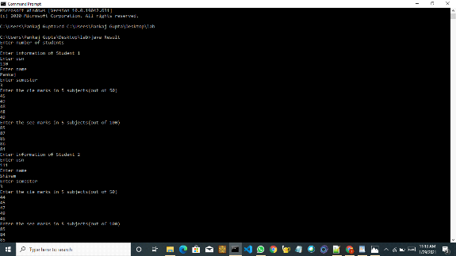

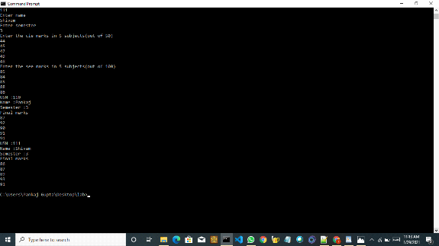

2.Write a program to demonstrate generics with multiple object parameters.

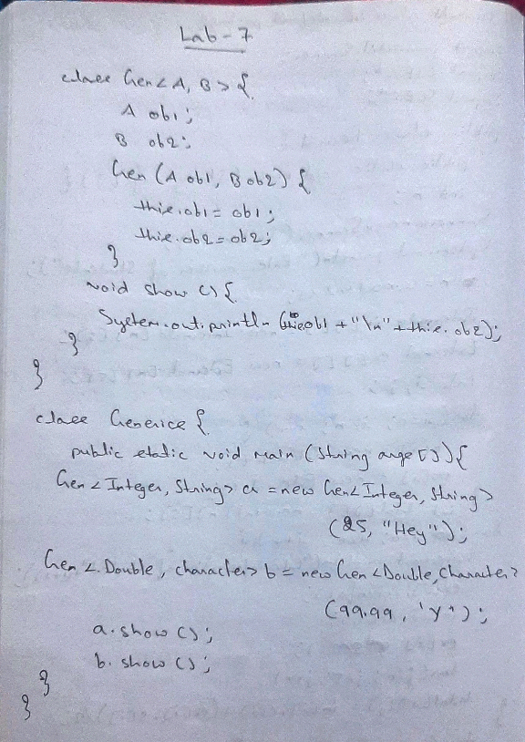

class Gen<A,B> {

A ob1;

B ob2;

Gen(A ob1, B ob2) {

this.ob1 = ob1;

this.ob2 = ob2;

}

void show() {

System.out.println(this.ob1+"\n"+this.ob2);

}

}

class Generics {

public static void main(String args[]) {

Gen<Integer,String> i = new Gen<Integer,String>(88, "90");

Gen<Integer,Double> f = new Gen<Integer,Double>(88,90.15);

Gen<String,Integer> s = new Gen<String,Integer>("Hello",50);

i.show();

f.show();

s.show();

}

}

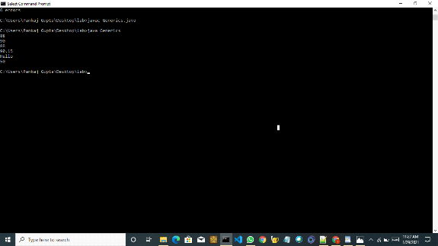

3.Write a program that demonstrates handling of exceptions in inheritance tree. Create a base class called “Father” and derived class called “Son” which extends the base class. In Father class, implement a constructor which takes the age and throws the exception WrongAge( ) when the input age<0. In Son class, implement a constructor that cases both father and son’s age and throws an exception if son’s age is >=father’s age.

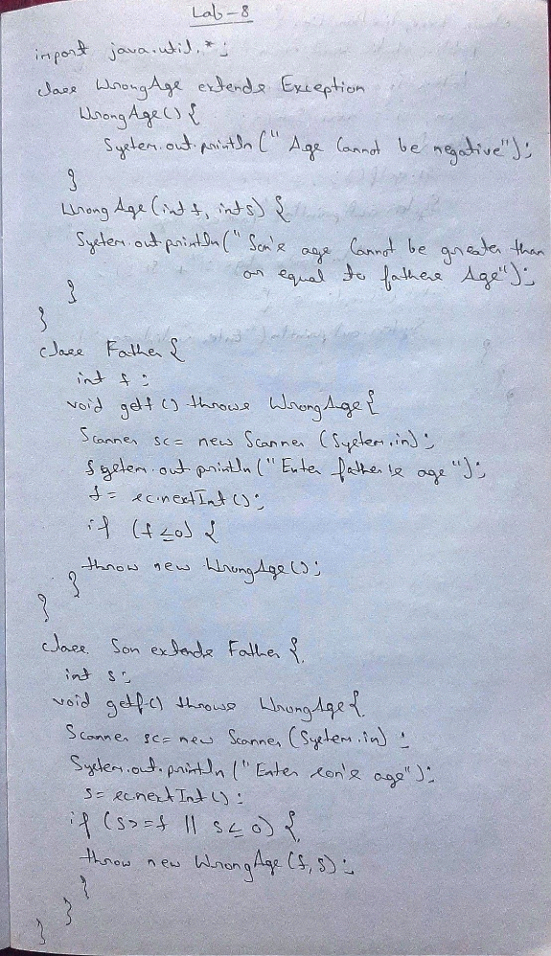

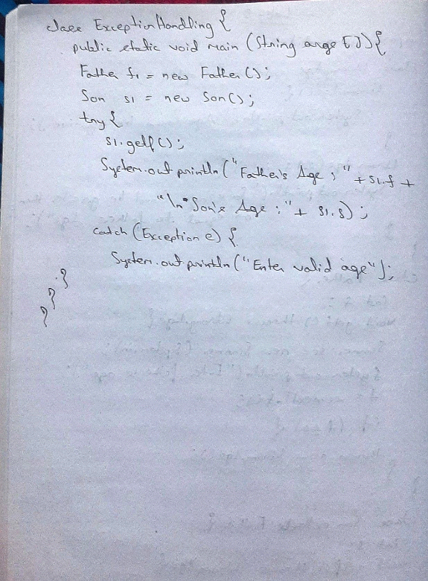

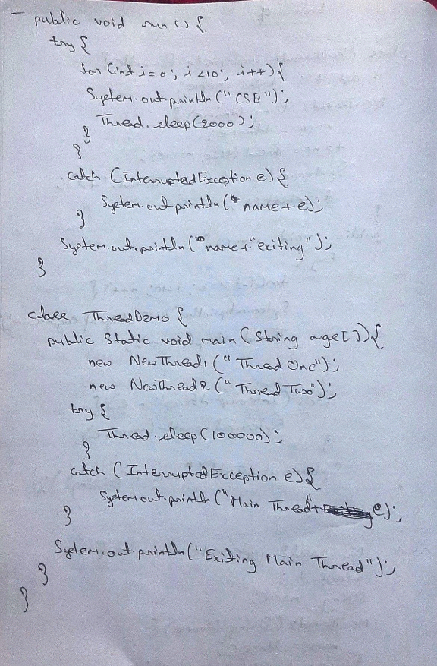

import java.util.\*;

class WrongAge extends Exception{

WrongAge(){

System.out.println("Age cannot be negative");

}

WrongAge(int f,int s){

System.out.println("Son's age cannot be greater than or equal to Fathers age");

}

}

class Father{

int f;

void getf() throws WrongAge{

Scanner sc=new Scanner(System.in);

System.out.println("Enter Fathers Age");

f=sc.nextInt();

if(f<0){

throw new WrongAge();

}

}

}

class Son extends Father{

int s;

void getf()throws WrongAge{

super.getf();

Scanner sc=new Scanner(System.in);

System.out.println("Enter son's age");

s=sc.nextInt();

if(s>=f || s<0){

throw new WrongAge(f,s);

}

}

}

class ExceptionHandling{

public static void main(String args[]){

Father f1=new Father();

Son s1= new Son();

try{

s1.getf();

System.out.println("Fathers Age :"+s1.f+"\nSon's Age :"+s1.s);

}

catch(Exception e){

System.out.println("Enter valid age");

}

}

}

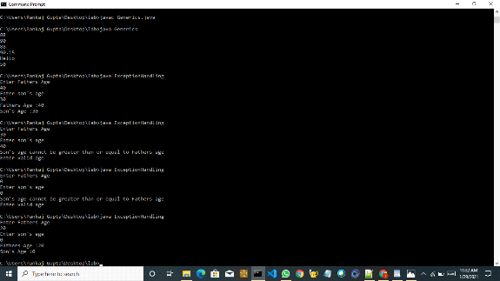

4.Write a program which creates two threads, one thread displaying “BMS College of Engineering” once every ten seconds and another displaying “CSE” once every two seconds.

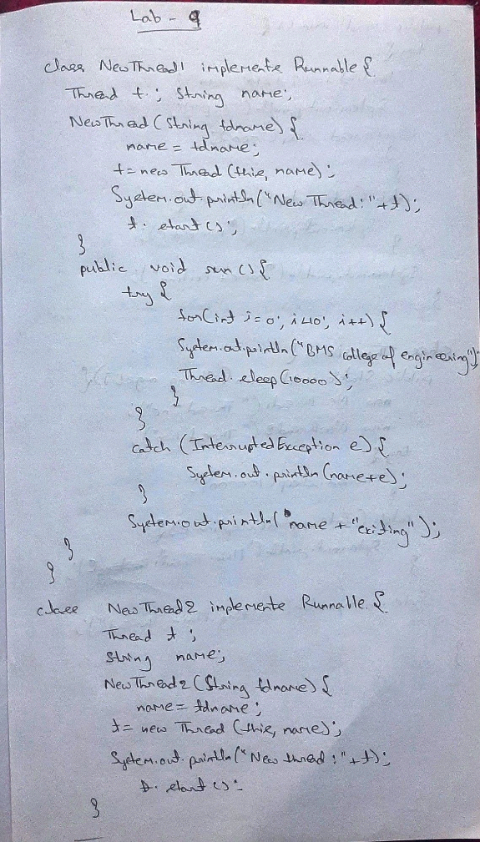



class NewThread1 implements Runnable{

Thread t;

String name;

NewThread1(String tdname){

name=tdname;

t=new Thread(this,name);

System.out.println("New Thread: "+t);

t.start();

}

public void run(){

try{

for(int i=0;i<10;i++){

System.out.println("BMS College of Engineering");

Thread.sleep(10000);

}

}

catch(InterruptedException e)

{

System.out.println(name +e);

}

System.out.println(name+" exiting");

}

}

class NewThread2 implements Runnable{

Thread t;

String name;

NewThread2(String tdname){

name=tdname;

t=new Thread(this,name);

System.out.println("New Thread: "+t);

t.start();

}

public void run(){

try{

for(int i=0;i<10;i++){

System.out.println("CSE");

Thread.sleep(2000);

}

}

catch(InterruptedException e)

{

System.out.println(name +e);

}

System.out.println(name+" exiting");

}

}

class ThreadDemo{

public static void main(String args[]){

new NewThread1("Thread One");

new NewThread2("Thread Two");

try{

Thread.sleep(100000);

}

catch(InterruptedException e){

System.out.println("Main Thread: "+e);

}

System.out.println("Main Thread exiting");

}

}

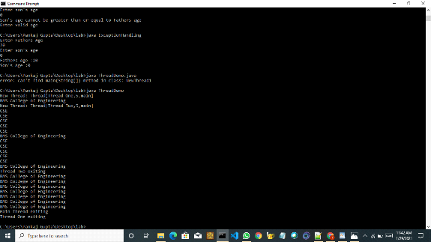

5.Write a program that creates a user interface to perform integer divisions. The user enters two numbers in the text fields, Num1 and Num2. The division of Num1 and Num2 is displayed in the Result field when the Divide button is clicked. If Num1 or Num2 were not an integer, the program would throw a NumberFormatException. If Num2 were Zero, the program would throw an Arithmetic Exception Display the exception in a message dialog box.

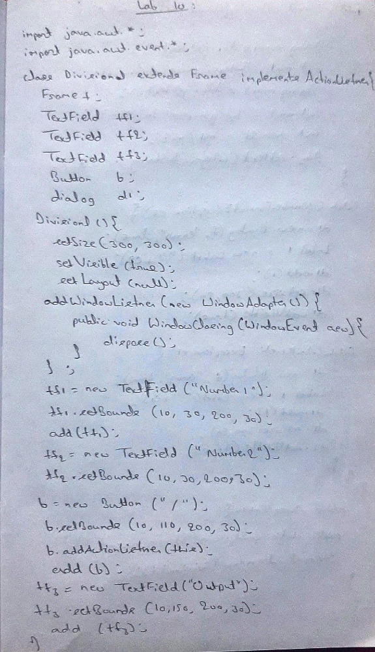

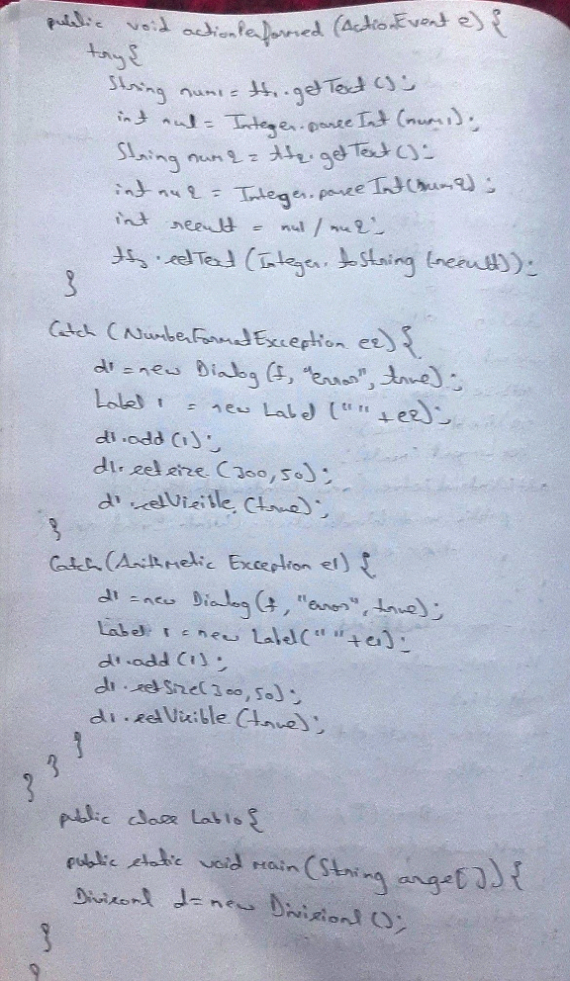

import java.awt.\*;

import java.awt.event.\*;

class Division1 extends Frame implements ActionListener{

Frame f;

TextField tf1;

TextField tf2;

TextField tf3;

Button b;

Dialog d1;

Division1(){

setSize(300,300);

setVisible(true);

setLayout(null);

//to colse window

addWindowListener(new WindowAdapter(){

public void windowClosing(WindowEvent aew){

dispose();

}

});

//textfield1 initialization

tf1 = new TextField("Number1");

tf1.setBounds(10,30,200,30);

add(tf1);

//textfield2 initialization

tf2 = new TextField("Number2");

tf2.setBounds(10,70,200,30);

add(tf2);

//division button creation

b = new Button("/");

b.setBounds(10, 110, 200, 30);

b.addActionListener(this);

add(b);

//textfield3 initialization

tf3 = new TextField("Output");

tf3.setBounds(10,150,200,30);

add(tf3);

}

public void actionPerformed(ActionEvent e){

try{

String num1=tf1.getText();

int nu1=Integer.parseInt(num1);

String num2=tf2.getText();

int nu2=Integer.parseInt(num2);

int result = nu1/nu2;

tf3.setText(Integer.toString(result));

}

catch(NumberFormatException e2){

d1 = new Dialog(f,"error",true);

Label l = new Label(""+e2);

d1.add(l);

d1.setSize(300,50);

d1.setVisible(true);

}

catch(ArithmeticException e1){

d1 = new Dialog(f,"error",true);

Label l = new Label(""+e1);

d1.add(l);

d1.setSize(300,50);

d1.setVisible(true);

}

}

}

public class Lab10 {

public static void main(String[] args) {

Division1 d = new Division1();

}

}

